

A Project Report On

**Grocery Delivery Application**

**By**

# Priyanka Patil

# Enrollment Number

# (EBEON1221507437)

**Batch:** 2022 – 6522

**Center: Thane**

Under the Guidance of, **Chittaranjan Gosh Technical Trainer**

**EduBridge**

(School of coding)

**Introduction:**

Our project explains about the Grocery Shopping Website Name Grocery store. This project mainly explains the various actions related to shop online. In this project the admin can Add, Update, and Delete products. The groceries are divided into various categories like Package food, Household care, Personal and Beauty & Dairy Products etc. A user can select a particular item to view the details of category product.

Project Include **Modules: -**

* Admin Module
* Customer Module

I have developed this Application in **Java, Rest Api, Hibernate and MySQL.** It’s a web-based projects so I have used **HTML, CSS, JavaScript and Bootstrap 5, Thymeleaf also**.

### Features: -

The main feature of the project is to make shopping easier. You can access this website from anywhere and everywhere.

1. In Admin module, admin can add, delete & update the Category and Products in the specific category. He can also view the total number of users & also he can update the order status at present in the website. Admin can also login and logout.
2. In User module, user can access the website and view the product. User can buy the product from cart and user can add and remove any category product from cart. New user can login but it is necessary to register him, after that he can do the login and logout and he can also change the password.

### Software Requirements:

* **Front end:** Java/J2EE technologies (Servlet, JSP), HTML, CSS, JavaScript, Bootstrap 5, Hibernate, Thymeleaf.
* **Back end**: MySQL workbench 8.0.23CE.
* **Middleware/Server:** Apache Tomcat v8.5. IDE: Spring Tool Suite (STS) for Java EE Developers.
* **Browser:** Best result on Google Chrome
* **Operating System:** Window 10.

# Data Dictionary:

* Create Database grocerydb;
* Tables of database grocerydb;

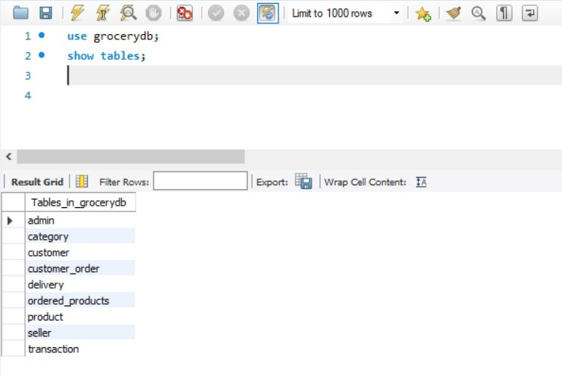

* **Hibernate: Category table**

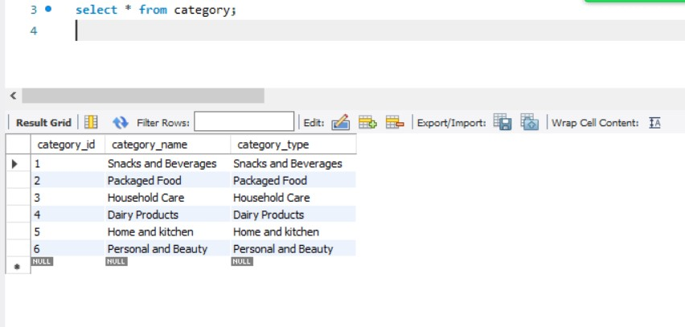

* **Hibernate: Seller table**

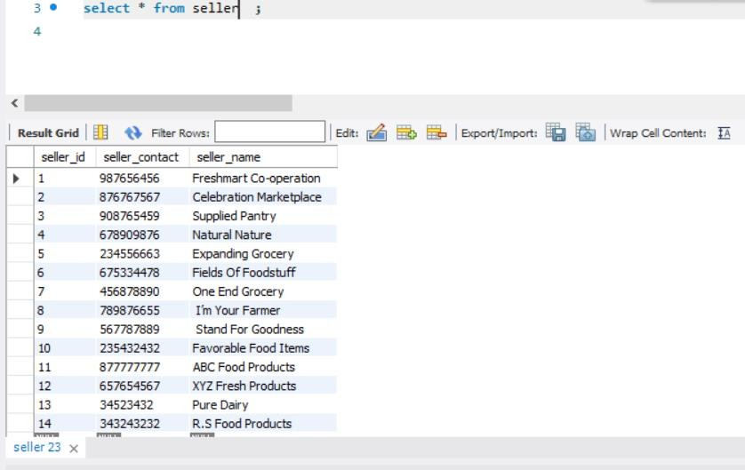

## Hibernate: Product table

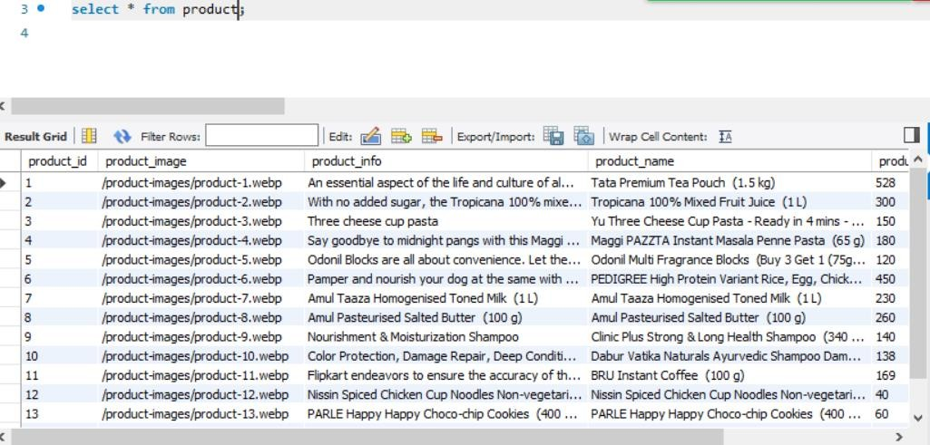

* **Hibernate: Customer table**

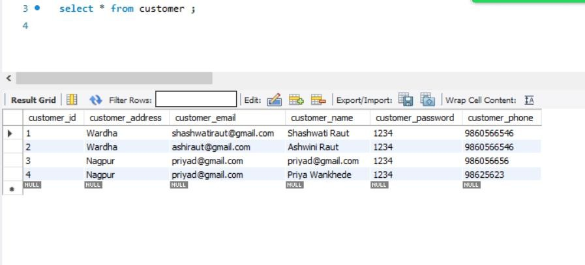

## Hibernate: Transaction table

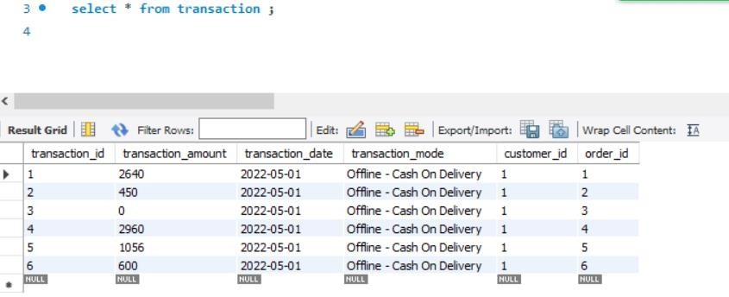

* **Hibernate: Delivery table**

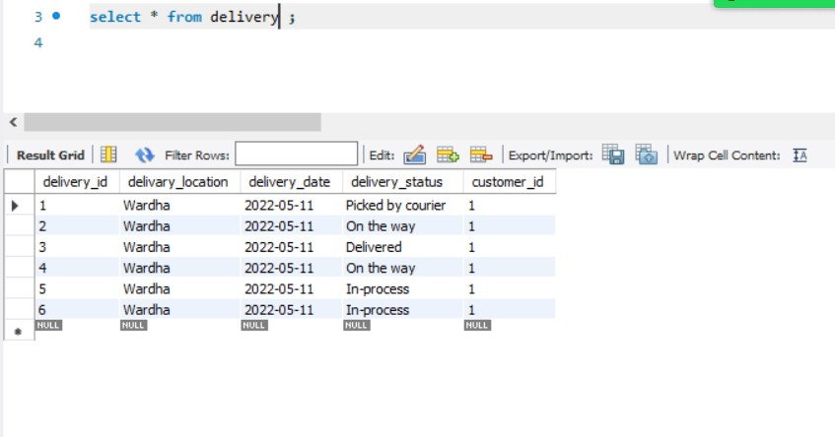

## Hibernate: Customer Order table

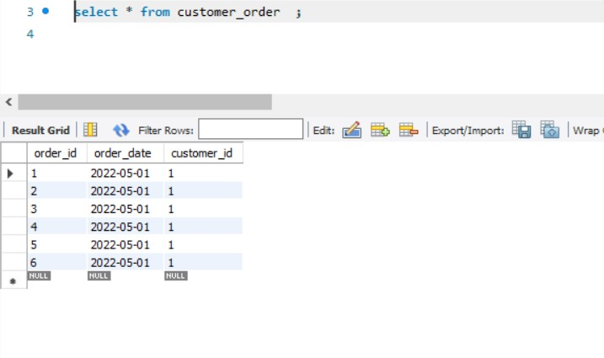

* **Hibernate: Ordered Products table**

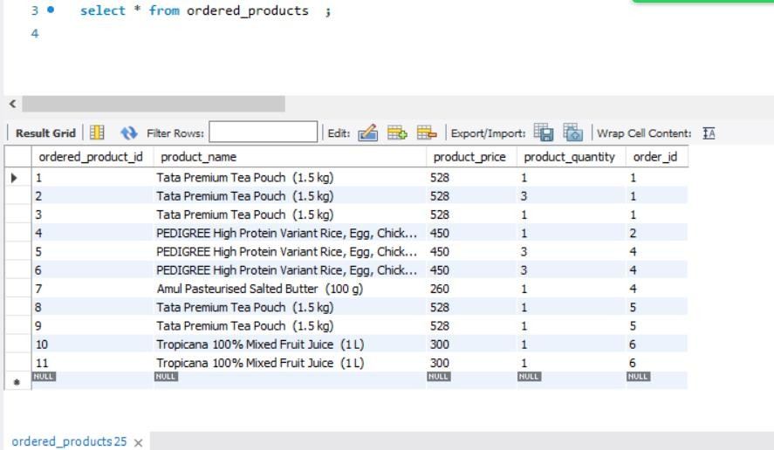

# Screenshots: -

* **Front End: Home Page**

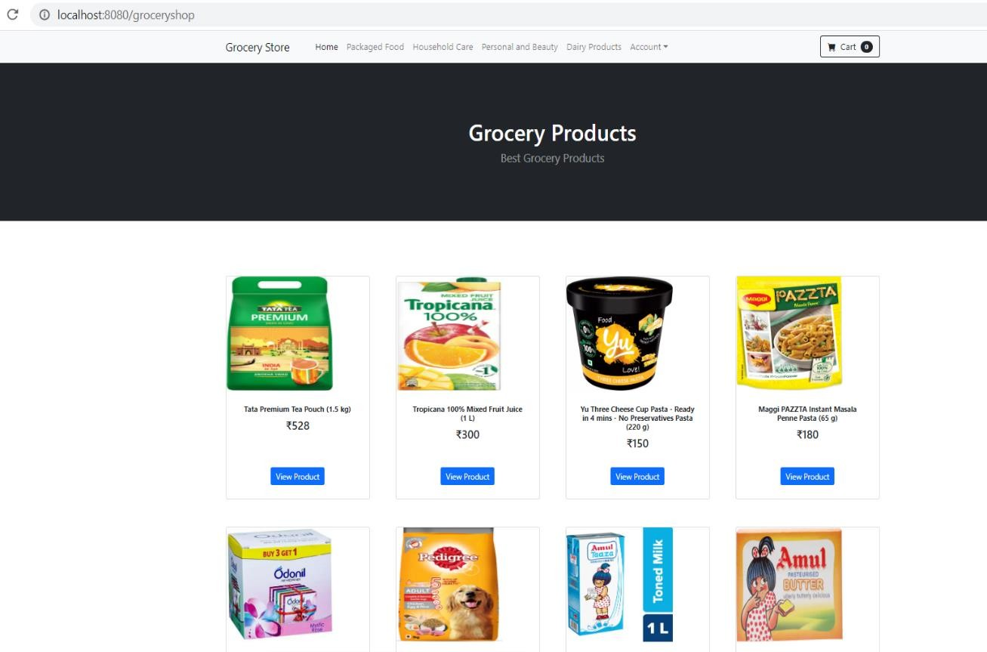

### View Product

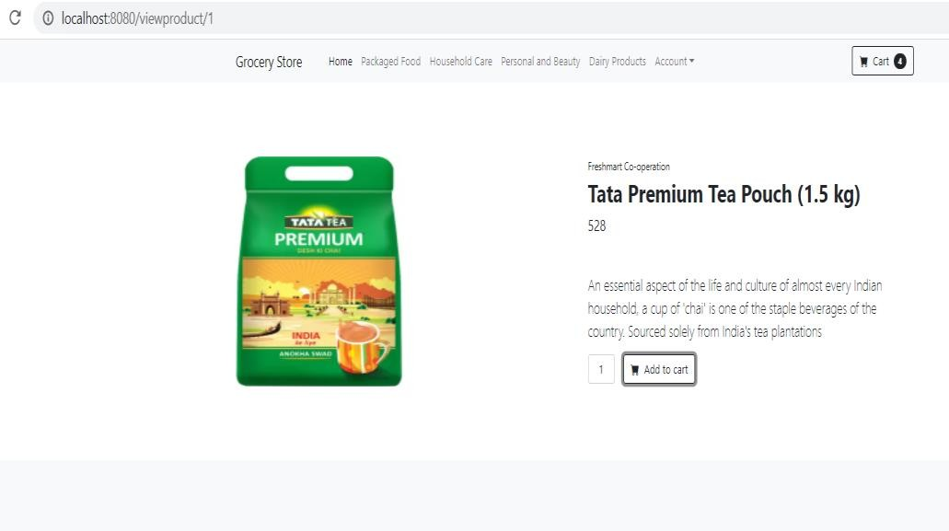

* **Login Page:**

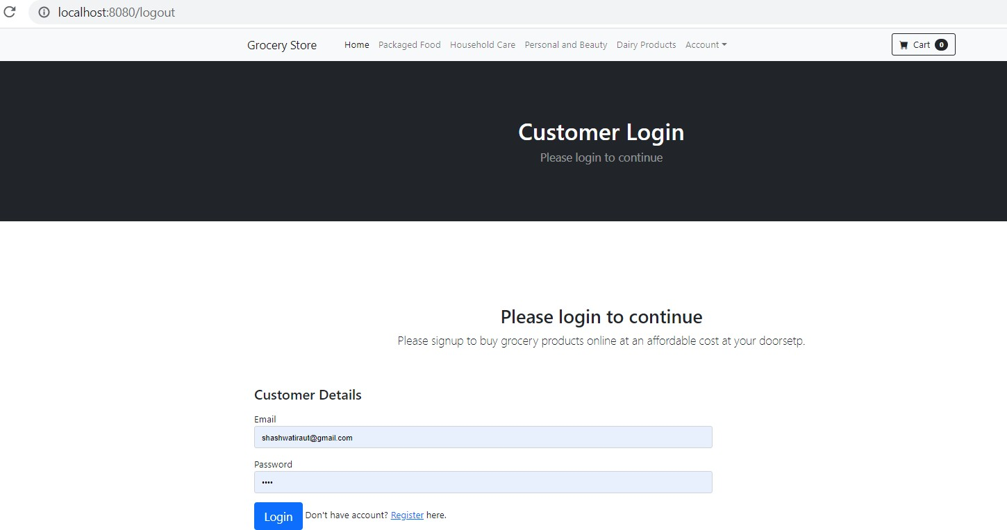

### Register Page

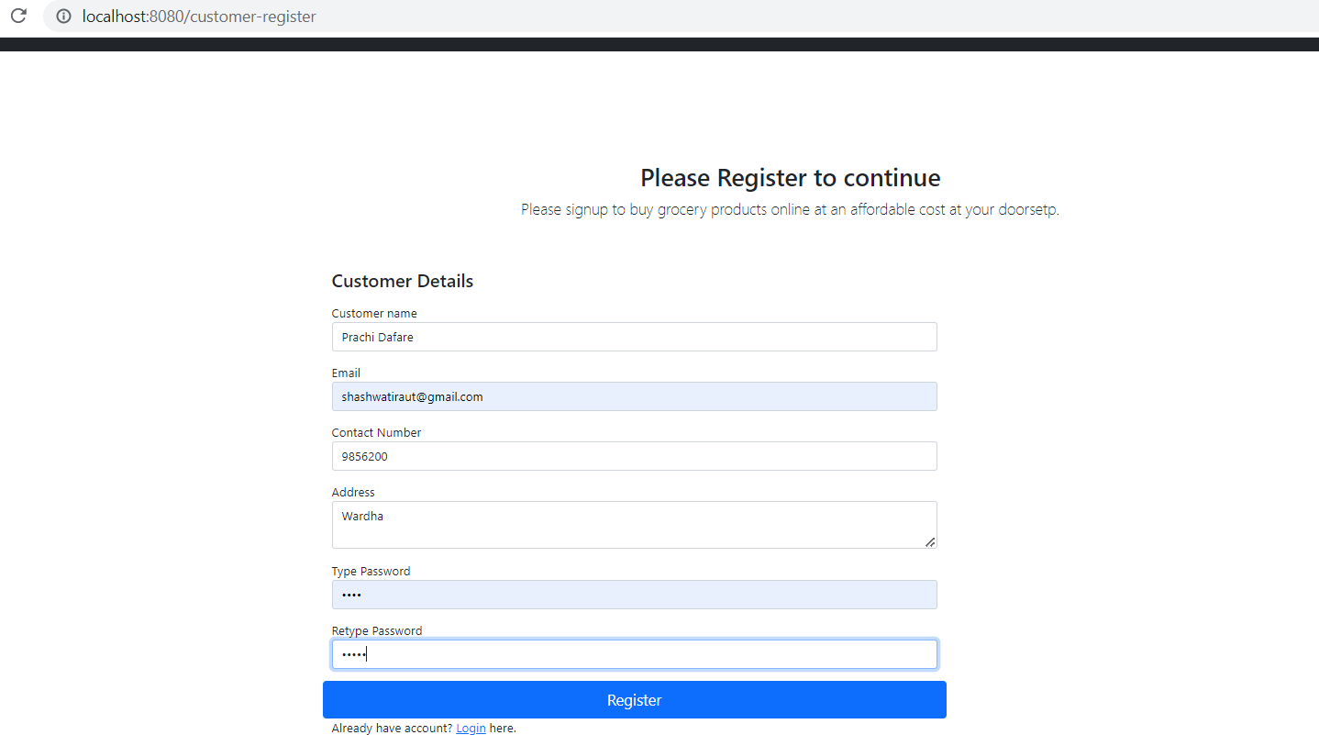

* **Order Status Page**

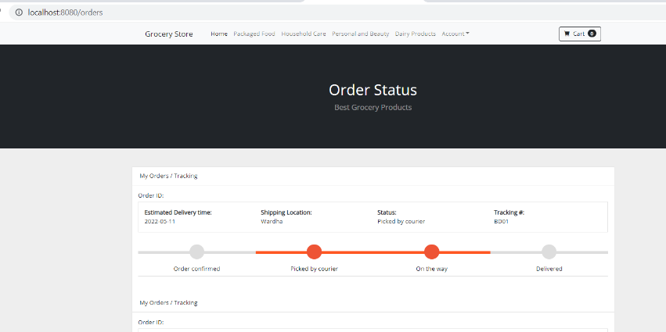

* **Back End: Admin**

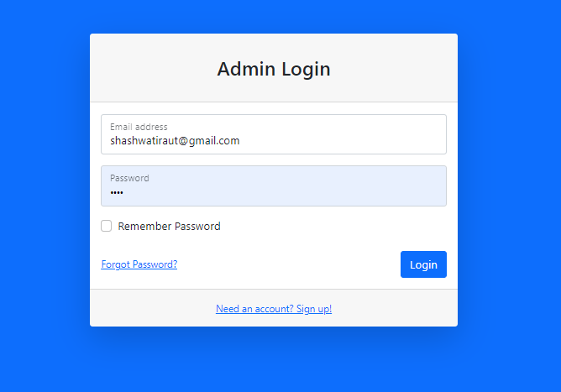

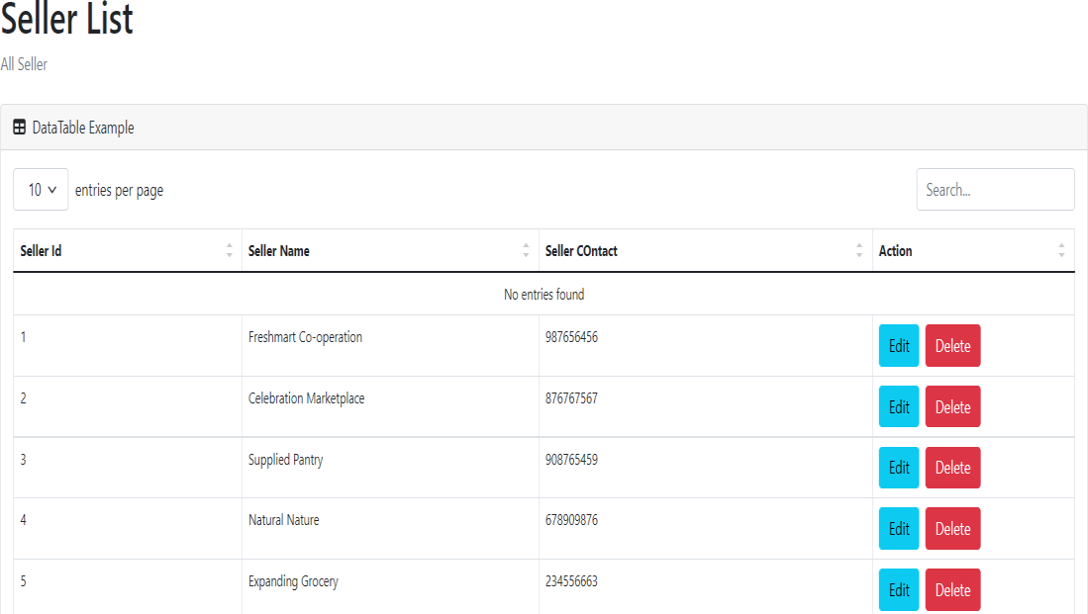

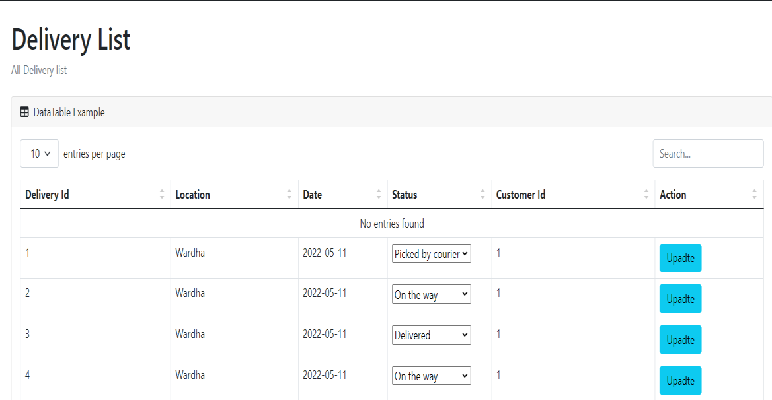

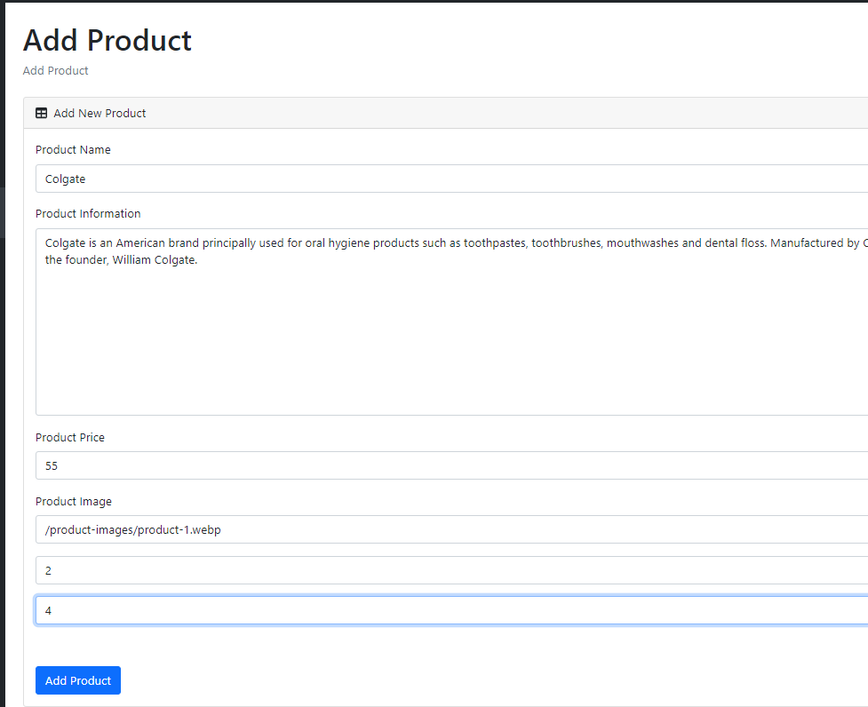

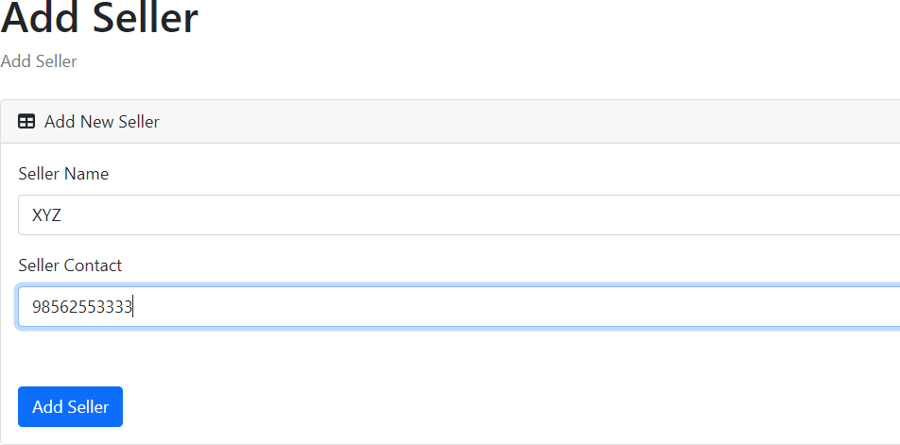

**Thank you**